**Exercise 1: Logging Error Messages and Warning Levels**

**Task:** Write a Java application that demonstrates logging error messages and warning levels using SLF4J.

**STRUCTURE:**

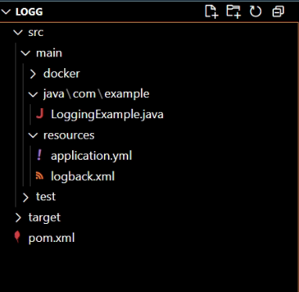

**CODE:**

**LoggingExample.java:**

package com.example;

import org.slf4j.Logger;

import org.slf4j.LoggerFactory;

public class LoggingExample {

    private static final Logger logger = LoggerFactory.getLogger(LoggingExample.class);

    public static void main(String[] args) {

        logger.error("This is an error message");

        logger.warn("This is a warning message");

        logger.info("This is an info message");

        logger.debug("This is a debug message");

    }

}

**logback.xml:**

<configuration>

    <appender name="CONSOLE" class="ch.qos.logback.core.ConsoleAppender">

        <encoder>

            <pattern>%d{HH:mm:ss.SSS} [%thread] %-5level %logger{36} - %msg%n</pattern>

        </encoder>

    </appender>

    <root level="debug">

        <appender-ref ref="CONSOLE" />

    </root>

</configuration>

**pom.xml:**

<project xmlns="http://maven.apache.org/POM/4.0.0"

         xmlns:xsi="http://www.w3.org/2001/XMLSchema-instance"

         xsi:schemaLocation="http://maven.apache.org/POM/4.0.0

         http://maven.apache.org/xsd/maven-4.0.0.xsd">

  <modelVersion>4.0.0</modelVersion>

  <groupId>com.example</groupId>

  <artifactId>mockito-demo</artifactId>

  <version>1.0-SNAPSHOT</version>

  <properties>

    <maven.compiler.source>11</maven.compiler.source>

    <maven.compiler.target>11</maven.compiler.target>

  </properties>

  <dependencies>

    <!-- SLF4J API -->

    <dependency>

        <groupId>org.slf4j</groupId>

        <artifactId>slf4j-api</artifactId>

        <version>1.7.30</version>

    </dependency>

    <!-- Logback as the SLF4J binding -->

    <dependency>

        <groupId>ch.qos.logback</groupId>

        <artifactId>logback-classic</artifactId>

        <version>1.2.3</version>

    </dependency>

</dependencies>

<build>

    <plugins>

        <plugin>

            <groupId>org.codehaus.mojo</groupId>

            <artifactId>exec-maven-plugin</artifactId>

            <version>3.0.0</version>

            <configuration>

                <mainClass>com.example.LoggingExample</mainClass>

            </configuration>

        </plugin>

    </plugins>

</build>

</project>

**CODE:**

